
Midwest Football Academy Grizz Sports 3rd Annual Invitational Football Tournament
Games played at Hart Park, Kettle Moraine High School, and Appleton Area High Schools.

5th, 6th, 7th (2 game guarantee) and 8th grade (Champion of each field will play a 3rd game) 1 game per day for all teams

Friday November 2nd (8th grade only), Saturday November 3rd, and
Sunday November 4th 2012. (All grades play on Saturday and Sunday)

Cost: $385 per team plus $5 per player on each team.
3 or more teams from same club receive a $35 discount per team
Entrance to field fee is $5 per adult and $2 twelve and under per day.

First 8 teams accepted per Grade

WIAA High School Football Officials will work every game.

All fields are FIELD TURF and players will be required to wear cleats.
Concessions will be served at the field. NO CARRY-INS

Excellent competition, only the best will be accepted.
Identification required. Eligibility date is September 1st.
Registrations accepted until October 1st, 2012
Questions Contact 414-336-2168 or bruce@grizzsports.com
Visit our website at www.grizzsports.com

Team Plaque and Trophies awarded to tournament champ and
Team Medals to 2nd place team
Team Medals to consolation winning team


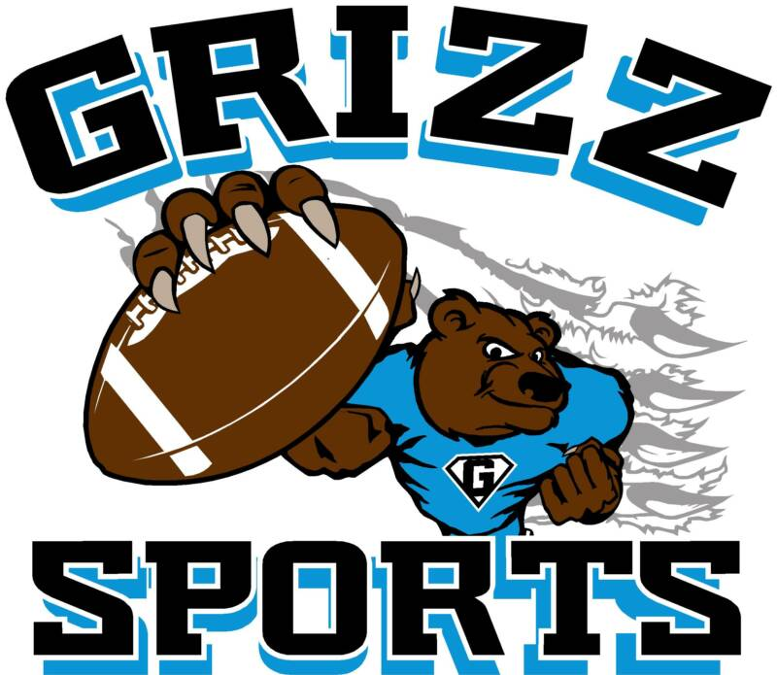
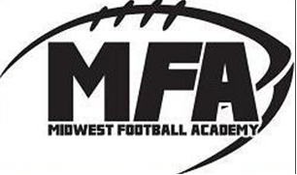
Football, the way it was meant to be played.

