
Midwest Football Academy/Grizz Sports Youth Invitational Football Tournament

Welcome to the 3rd Annual Youth Invitational Football Tournament. Thank you for giving us the pleasure of hosting your team. If you have any questions or constructive criticisms please contact us. We truly want this to be the best football experience your team has ever had.

Hart Park
1299 N 72nd St
Wauwatosa, Wisconsin 53213
Or
Kettle Moraine High School
349 N Oakcrest Dr.
Wales, WI 53183
- Warm up will be on grass fields adjacent to the Stadium. Your team will be expected to be ready to play at the scheduled time.
- Team listed 1st on the schedule will occupy the east sideline. The team listed 2nd will occupy the west sideline.
- Team listed first will be asked to provide 3 volunteers for chain gang for the entire game.
- After game handshakes please police your bench and leave field promptly so the next game can commence on time.
- Each team will provide one spotter in the press box to identify players on field to announcer.
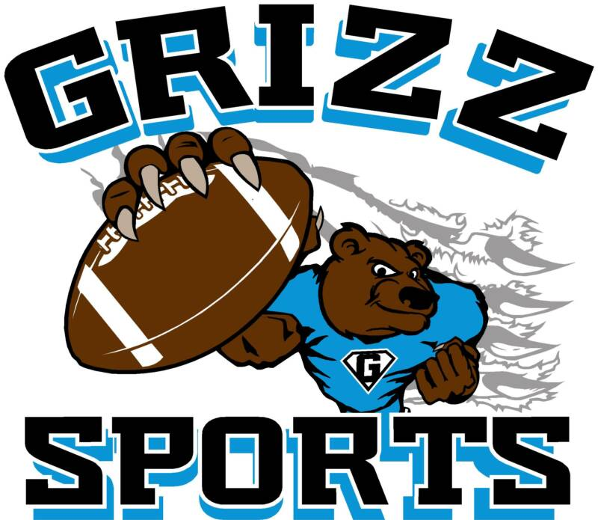
- Only water will be allowed on the field.
- Grizz Sport Attendants will be identified by bright orange t-shirts. Please feel free to see these Attendants with any questions or concerns.
- Prior to 8th grade championship game the National Anthem will be played. Please have your team ready to respect our country.

- Your team will have complete access to press box during your entire scheduled game. Videotaping or picture taking from this location is encouraged.
- A Grizz Sport Attendant will provide your team with tee shirts and appropriate awards immediately after your final game.
- NO CARRY-INS will be allowed. Complete concessions will be available for purchase.
- Entrance will be on the Southeast side of the field.
- Entrance to field fee is $4 per adult and $2 fourteen and under per day

Have a great weekend of football.
Grizz Sports/Midwest Football Academy
